**Rimbaud, Jean Nicolas Arthur (1854-1891)**

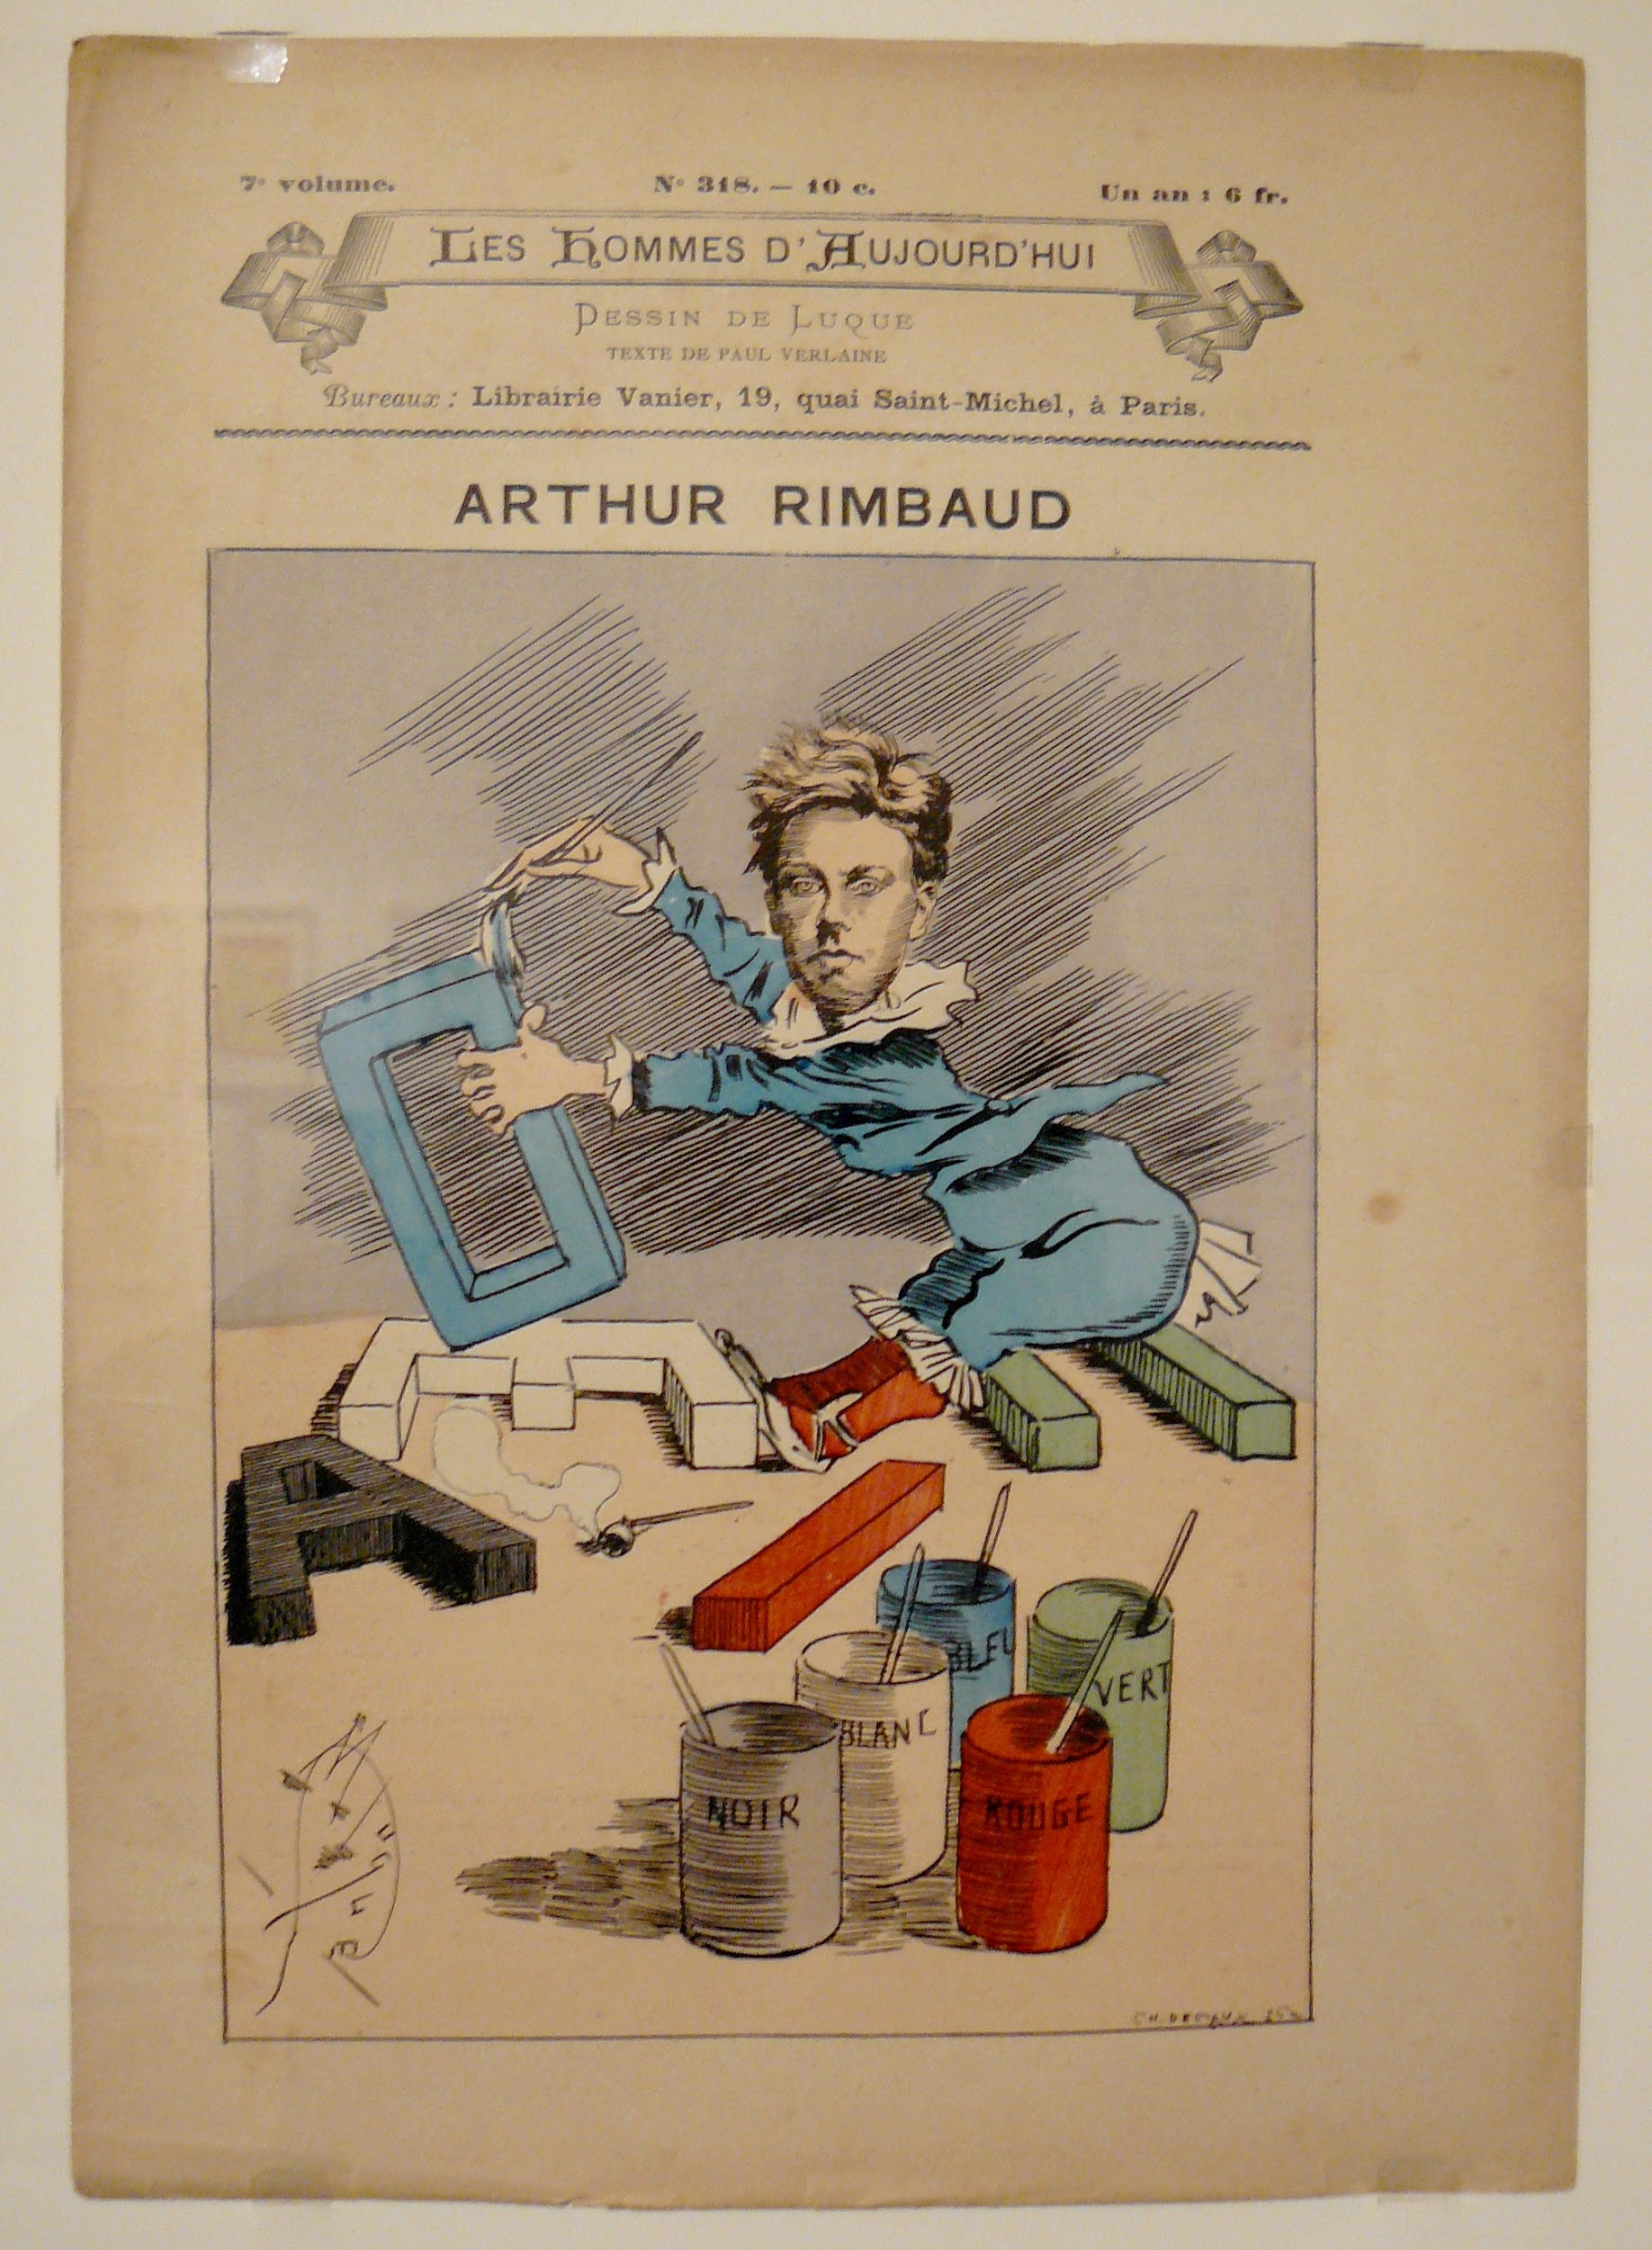

(Caricature of Rimbaud by Luque, 1888, [CC BY-SA 3.0](https://fr.wikipedia.org/wiki/Arthur_Rimbaud#/media/File:Rimbaud_Voyelles_caricature.jpg))

Late 19th-century French Poet Arthur Rimbaud is known just as much for his poetic production as for his personality. His contributions to Modernist verse and aesthetics, and to Symbolism, are major, insofar as he created a language of dissonance and discordance — in terms of rhythm and meter, sound, image, and vocabulary. This discordant language is a language of potential and openness made possible through the “correspondences” (“correspondances” in French) between the senses, often described in Rimbaud as “synaesthetic,” something he developed from Baudelaire’s notion of “correspondance,” or the association between the senses, meanings, the aesthetic and the play of these with the “spirit” (both mind and spirit). Where early Symbolists focused on the image, and Rimbaud’s contemporaries Mallarmé and Verlaine brought verse closer, respectively, to the Idea music and to melody, Rimbaud brought all the senses to a dislocation or a derangement (“dérèglement”). This derangement also frequently involves the sense of smell, and even the idea of allocating colours to vowels (in his famous sonnet “Voyelles”). This process also opened up the notion of interpretation and furthered a Symbolist aesthetic of “suggestion,” thereby pushing the limits of the known in order to find new experiences and sensations. Rimbaud characterized this new experience, the poet’s task, as that of a “voyant” (seer) in his famous “lettre du voyant” to Paul Demeny (May 15, 1871), where poetry creates new, unheard and unknown visions. For Rimbaud, this requires a superhuman power — involving even illness, crime, damnation — to make of him a “Savant” who, beyond intelligence, will have “seen.”

For Rimbaud, pushing the limits was not just an aesthetic ideal or a game of poetic language, but was also a lifestyle. He is known, along with Baudelaire, Verlaine, Lautréamont and others, as an example of the “poet of the damned” (“poète maudit”) par excellence. He spent two years with Verlaine in homosexual relationship, living a vagabond, drug-induced lifestyle as an anti-social rebel, a wild enfant terrible, and as a revolutionary. Even within the circles of the anti-social poets, he was scandalous for his bad behaviour. It is in this period that the greatest part of his poetic production occurred. Just as meteoric as his career was the mysterious departure from the literary field and his abandoning the poetic métier altogether. He later travelled in Africa, working as a merchant and arms dealer, and much has been made of his departure from poetry in biographical and thematic terms, the mystery of which is subject to conflicting interpretations.

Much as you might admire the work of Rimbaud and his life, you might not actually have enjoyed meeting him as there is a strong chance would have offended you. His reputation as an enfant terrible eventually led him to be snubbed by Parisian literary circles. Rimbaud was born on October 20, 1854 at Charleville (his family's farm was in Roche, near Charleville on the French-Belgian border). He showed himself to be a brilliant student, and at sixteen, in 1870, published *Etrennes des orphelins* in *Revue pour tous*, though this success was accompanied by rebelliousness. In the summer of the same year he ran away to Paris and was subsequently incarcerated. He ran away again in the autumn. In February of 1871, a revolutionary year, involved a sordid winter of misery, in which he made a third escape to Paris with 15 days of abject misery. Between March and May, during the Paris Commune, Rimbaud’s poetry became increasingly radical. It is at this time that he sent the “voyant” (“seer”) letters to Izambard (teacher and ex-mentor) and Demeny, where he elaborates his theory of “objective poetry.” The summer was triumphant, but the eventual defeat of the Commune left Rimbaud with a feeling of bewilderment and strengthened his feelings of revolt. It’s in this year that he wrote some of his most revolutionary early poems, such as “Le Bateau ivre” (“The Drunken Vessel”), and formal experiments such as “Voyelles” (“Vowels”). This poetry frequently attacks the Catholicism and Bourgeois conformism of Napoléon III’s new France.

In 1872, Rimbaud and Verlaine began a sexual affair, consuming absinthe and hashish, arriving London in September where they lived in poverty. In the spring of 1873, Rimbaud began writing *Une Saison en Enfer* ("A Season in Hell") during a family visit. In the following weeks, Rimbaud travelled with Verlaine to Belgium and London. Verlaine, suicidal and abusing alcohol, fought frequently with Rimbaud. After a bitter separation, Verlaine and Rimbaud reunited but continued to fight. In July in Brussels, after Rimbaud said he would leave, Verlaine fired three shots from his revolver, wounding Rimbaud on the wrist. Initially doing nothing about it, Rimbaud pressed charges when Verlaine threatened him. Verlaine was arrested and incarcerated, serving two years of hard labour. Rimbaud later published *Une Saison...*, but it was negatively reviewed, most likely because of his bad reputation and mistreatment of Verlaine.

There is much speculation (without any conclusive ideas) as to why Rimbaud abandoned the poetic métier. However, it is unlikely the relationship with Verlaine that is exclusively the cause, and it is certainly not in a linear causal way. Though Rimbaud admits to the defeat of his modernist project in *Une Saison...*, which recounts in part his affair with Verlaine, he did complete *Illuminations* a year later, a prose-poem experiment that further develops his poetics. Rimbaud and Verlaine met for the last time in 1875. That year, Rimbaud worked and traveled Europe on foot. In 1876, he was a soldier in the Dutch Colonial Army in the Dutch East Indies. He deserted and returned to France, something for which he could have been executed. In the years 1878 to 1891, he worked in Works in Cyprus, in Abyssinia (for company as a merchant), and ran a company in Harrar. He became an independent merchant of coffee and weapons. In 1891, he returned to France after suffering from pains, most likely from bone cancer. He died on November 10, 1891.

Ultimately, Rimbaud’s poetics can be described as absolute dissonance: the rupture, disorder, and vibration of chaos. The reader, much as with many a modernist text, must grasp themes intuitively. Such a poetry demonstrates a great sensory power. Where Mallarmé introduced a complex, dissonant (however, not chaotic) syntax, Rimbaud introduces chaotic ideas and vocabulary in simple syntax. Rimbaud is also a key inventor of “objective poetry,” in which the poetic subject doesn’t express an inner depth, as with the Romantics. In Rimbaud’s famous statement, “JE est un autre” (“I is an other,” in the “lettre du voyant”), he invents an exterior subject or self. This otherness involves a movement and requires exiting the self, where the self joins the horizons and limits of the poem, the subject being thus defined by its alterity rather than by its identity (Michel Collot, “Le sujet lyrique hors de soi” in Rabaté, 117). As to whether this other is a radical other, or whether it remains within the confines of the self insofar as it is auto- or self-fictional, is up to debate. In any case, the idea was to exit this self and find the unknown, to see that self from a hitherto unthinkable and unknowable experience.

His poetry attained to the intensities of experience, reaching for an ineffable world beyond reality. In order to do this, a new language was required. Such a language would play with the possibilities of poetic language, and saw language as incantatory. *Une Saison…* reached for a superhuman experience described in his “lettre du voyant,” and this required an “Alchimie du Verbe” (a verbal alchemy) that ends with a painful, humiliating, but ultimately defiant and ironic, defeat, in the words “il faut être absolument moderne” (“one must be absolutely modern”). The Illuminations, inspired by “painted plates” (“enluminures”) is a prose poem with hallucinatory visions. As he claims, “j’ai seule la clef de cette parade sauvage” (“only I have the key to this savage parade” — Parade); yet the danger is that the images brought forth remain so foreign that we cannot access them. Still, the aim is to embrace their carnal flavour and savageness, their uncanny strangeness, such as in “J’ai tendu des cordes de clocher en clocher ; des guirlandes de fenêtre à fenêtre ; des chaînes d’or d’étoile à étoile” (“I hung from the cords from bell to bell ; from garlands from window to window ; from golden chains from star to star”).

**Timeline of Works**

**1865**: *Prologue* (childhood composition)

**1870**: *Charles d’Orléans à Louis XI* (school composition for rhetoric class)

**1870**: *Un cœur sous une soutane* (suppressed until 1924 by Isabelle Rimbaud)

**1870-72**: *Poésies*, *Album zutique, Vers nouveaux*: variously composed poems until 1872, after which Rimbaud exclusively composed prose poems

**1873**: *Une Saison en Enfer*, an extended poem in prose

**1873-75**: *Illuminations*

**References and Further Reading**

Collot, Michel. “Le sujet lyrique hors de soi” in Jean-Michel Rabaté, *Figures du sujet lyrique*, Paris, PUF, 1996.

Hackett, Cecil Arthur. *Rimbaud: A Critical Introduction*. Cambridge: Cambridge University Press, 1981 (2010 for Digital ed.).

Rabaté, Jean-Michel. *Figures du sujet lyrique*, Paris, PUF, 1996.

Robb, Graham. *Rimbaud*. Norton/Picador, 2001.

Steinmetz, Jean-Luc. *Arthur Rimbaud. Presence of an Enigma*, Jon Graham trans. New York: Welcome Rain Publishers, 2001 (1991 for the French).

White, Edmund. *Rimbaud. The Double Life of a Rebel*. New York: Atlas & Co., 2008.